Games Development Project

*Interloper*

Leon Irving B00301496

# Project Plan

## Team List

**Leon Irving B00301496**:

* 3D Art
* Code Implementation
* Level Design
* Game Design
* Technical Design
* Documentation

Prior Experience: Unreal Engine 4, Blender, Maya, Photoshop, C#, HTML, JavaScript, CSS

Portfolio: <https://leonirving.wordpress.com/portfolio/> , <https://www.artstation.com/leon_irving_game_dev>

## Project Overview

A single player sci-fi themed first-person shooter game. The player will progress through levels by following objectives, fighting through different enemies, whilst picking up a variety of upgrades and weapons. The player can choose which level to play depending on which door hey enter from the central hub area. Once the player reaches the end of the level by completing all objectives, they will be faced with a single stronger enemy boss, which they must fight in a dedicated arena. Once this boss is defeated the level is complete and the player returns to the hub area. This game is also intended to convey a certain level of immersion and atmosphere through graphics and sound.

## Development Environment

Unreal Engine 4 using Blueprint Scripting for implementation of code and assets.

Trello for project management and planning.

Git/GitHub and Google Drive for version control: <https://github.com/LeonIrving/Interloper>

## Development Plan

Term 1

|  |  |  |  |  |  |  |  |  |  |  |  |  |
| --- | --- | --- | --- | --- | --- | --- | --- | --- | --- | --- | --- | --- |
| **Week** | 1 | 2 | 3 | 4 | 5 | 6 | 7 | 8 | 9 | 10 | 11 | 12 |
| Planning |  |  |  |  |  |  |  |  |  |  |  |  |
| Research |  |  |  |  |  |  |  |  |  |  |  |  |
| Code |  |  |  |  |  |  |  |  |  |  |  |  |
| Visuals |  |  |  |  |  |  |  |  |  |  |  |  |
| Level Design |  |  |  |  |  |  |  |  |  |  |  |  |
| Testing |  |  |  |  |  |  |  |  |  |  |  |  |
| Documentation |  |  |  |  |  |  |  |  |  |  |  |  |

Term 2

|  |  |  |  |  |  |  |  |  |  |  |  |  |
| --- | --- | --- | --- | --- | --- | --- | --- | --- | --- | --- | --- | --- |
| **Week** | 1 | 2 | 3 | 4 | 5 | 6 | 7 | 8 | 9 | 10 | 11 | 12 |
| Planning |  |  |  |  |  |  |  |  |  |  |  |  |
| Research |  |  |  |  |  |  |  |  |  |  |  |  |
| Code |  |  |  |  |  |  |  |  |  |  |  |  |
| Visuals |  |  |  |  |  |  |  |  |  |  |  |  |
| Level Design |  |  |  |  |  |  |  |  |  |  |  |  |
| Testing |  |  |  |  |  |  |  |  |  |  |  |  |
| Documentation |  |  |  |  |  |  |  |  |  |  |  |  |

## Risk Analysis

|  |  |  |
| --- | --- | --- |
| **Risk** | **Resources** | **Impact** |
| Creation of artificial intelligence;  *Implementation of a system which reacts to player actions, follows nav meshes, decides on actions etc.* | Code Implementation | 2 weeks |
| Using most up to date engine version;  *Using version 4.20, as the engine projects are not backwards compatible, halts direct implementation when using lab machines.* | Development environment | 1 week |
| Single Developer;  *One development team member, requiring higher workload in many aspects of project development* | Most areas of development | 2 weeks |

# Project Management

## Minutes

### Week 2

* Determined roles
* Decided game development environment; decided on Unreal Engine
* Brainstormed game ideas
* Started planning and documentation

### Week 3

* Continued planning and documentation
* Outlined game ideas
* Started game design document
* Initiated project management resources

### Week 4

* Completed initial planning
* Continued documentation
* Started technical design document

### Week 5

* Started implementation; base controls, modular weapon system
* Expanded technical design
* Continued testing of features throughout

### Week 6

* Continued implementation
* Continued documentation
* Continued resource and research gathering

### Week 7

* Began level design and implementation
* Further research into materials and lighting
* Creation of modular enemy character system with accompanying modular projectiles
* Refinement of weapon system

### Week 8

* Creation of game narrative and story
* Began pause menu implementation
* Further level design; boss arena, boss door, jump pads, lighting update
* Began boss fight implementation
* Implementation of objective system; key/door system, UI elements
* Further weapon and AI class improvements

### Week 9

* Objective system implementation
* Weapon system fixes
* Level visual improvements
* User Interface expansion

### Week 10

* Audio improvements
* Weapon pickup system
* Updated objective system
* Initial player data save implementation
* Began Presentation development

### Week 11

* Completed presentation
* Objective waypoints
* Gameplay video
* Updated enemy visuals
* Updated boss fight mechanics

### Week 12

* Begun critical appraisal
* Finalised documentation

## Version Control

### Trello

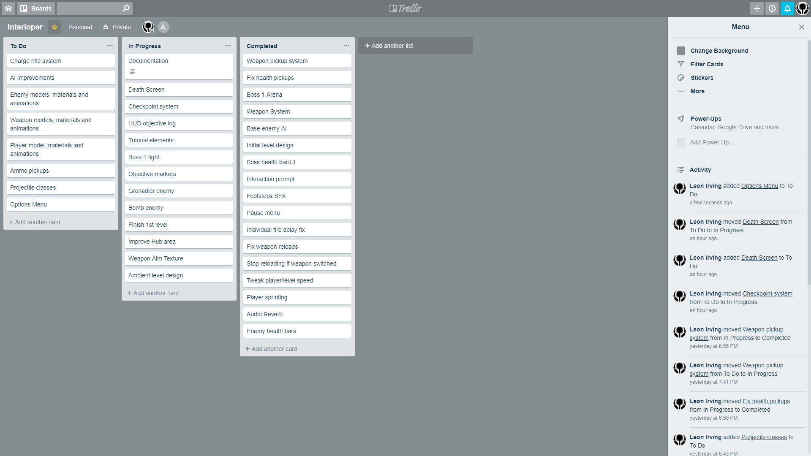

Trello was a useful project management tool for the duration of this project. It allows flexible creation and assignment of tasks with relation to different areas of the project. In this case, it was used to create three categories of implementation for any design features and they’re state within development; ‘To Do’, ‘In Progress’ and ‘ ‘Completed’. Therefore features or bug fixes etc. could be tracked and organised throughout development, as well as being allocated priority depending on the timescale granted to the feature.

### Git

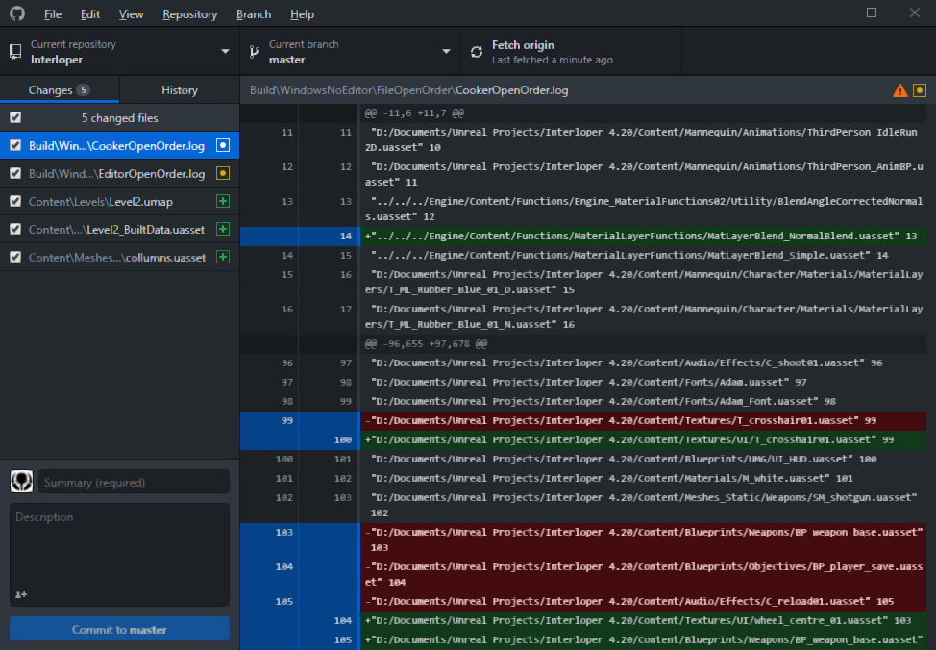

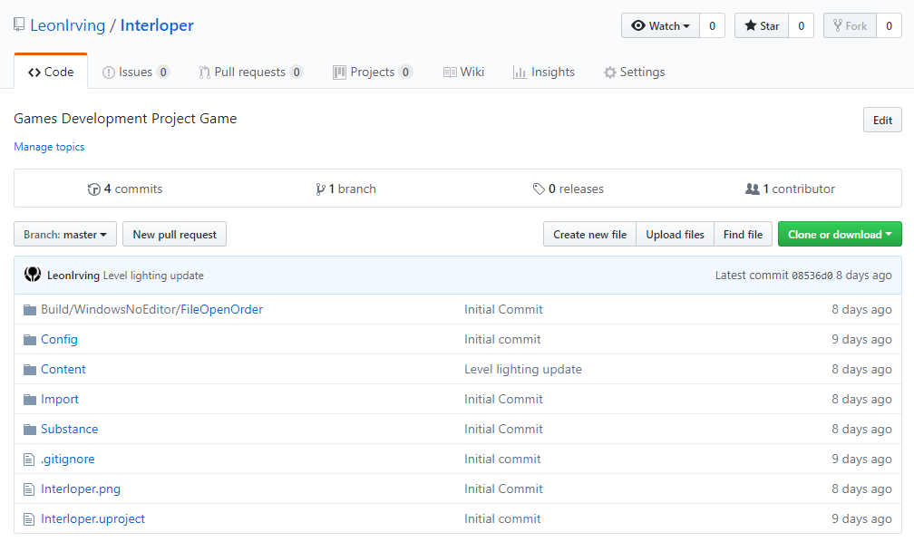

To ensure protection against data loss and as recourse in the event of data structure failure, version control was used in the form of project backups to external drives, as well as cloud storage of documents and project files to Google Drive. During the project Git implementation was also used, this was achieved through the use of the in-built Git plugin for Unreal Engine 4, allowing the use of source control from inside the engine. This allowed easy tracking of individual assets with an indication of whether the asset was yet to be added to or updated on version control. The GitHub desktop app was also useful in managing committed changes from Git to the cloud save of the project on Github.com.

# Game Design

## Overview

This game is a sci-fi single player first person shooter. The player moves through levels, fighting bosses and lesser enemies, while acquiring new weapons and abilities. To progress the player must explore the levels to complete objectives and defeat bosses. The player will be able to pick up items to replenish health and ammo etc. as well as new weapons to use throughout the level. The game will be 3D as the first person shooter genre is most effective in this form.

## Market Research

### Intended Audience

People who enjoy first person shooters, games with progression systems, a minimalist/sci-fi aesthetic style.

### Gameplay Inspiration and Influences

This game is inspired by existing successful and popular shooters and sci fi games. Reference and inspiration was taken from the various system which make up these experiences, from the first person control scheme to the environment design etc.

*DOOM*

[https://en.wikipedia.org/wiki/Doom_(2016_video_game)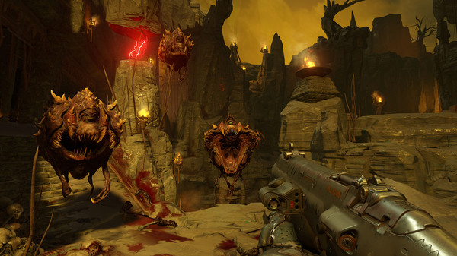](https://en.wikipedia.org/wiki/Doom_(2016_video_game))

*Destiny*

<https://en.wikipedia.org/wiki/Destiny_(video_game)>

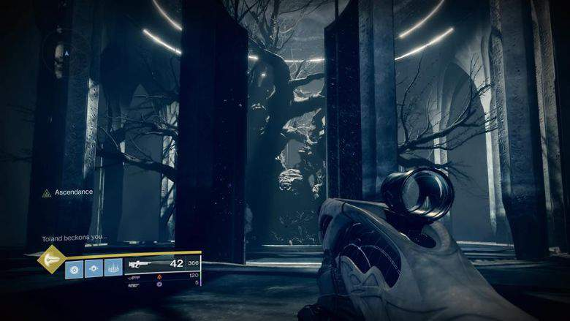

*Borderlands*

<https://en.wikipedia.org/wiki/Borderlands_(video_game)>

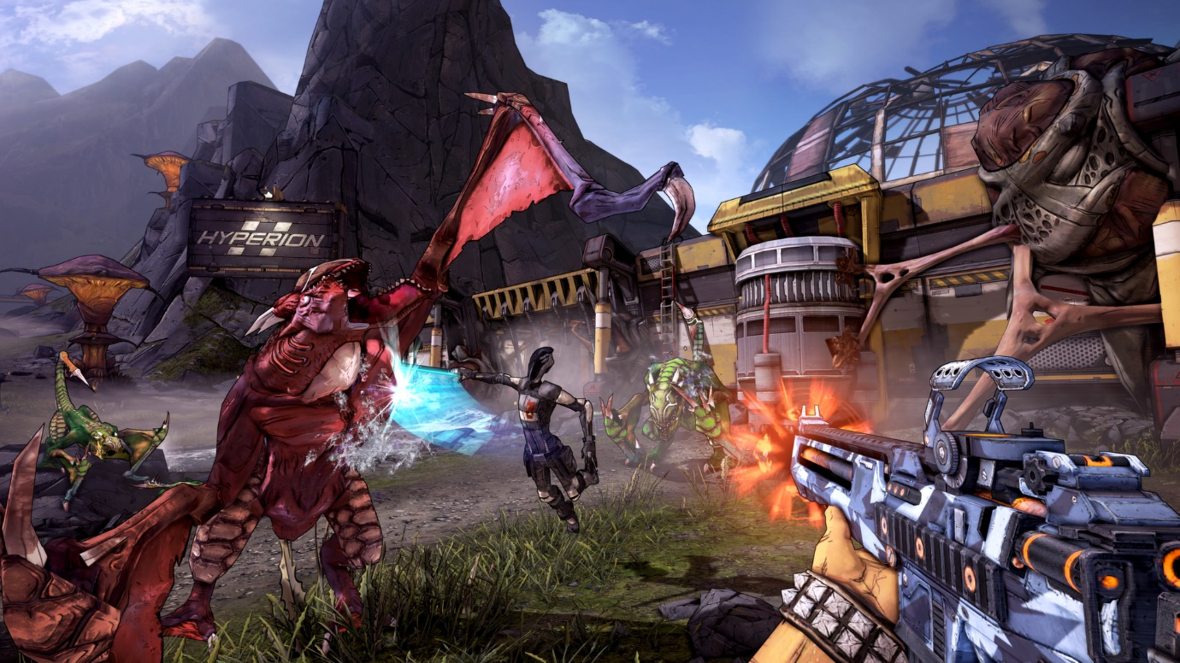

*Shadow Warrior 2*

<https://en.wikipedia.org/wiki/Shadow_Warrior_2>

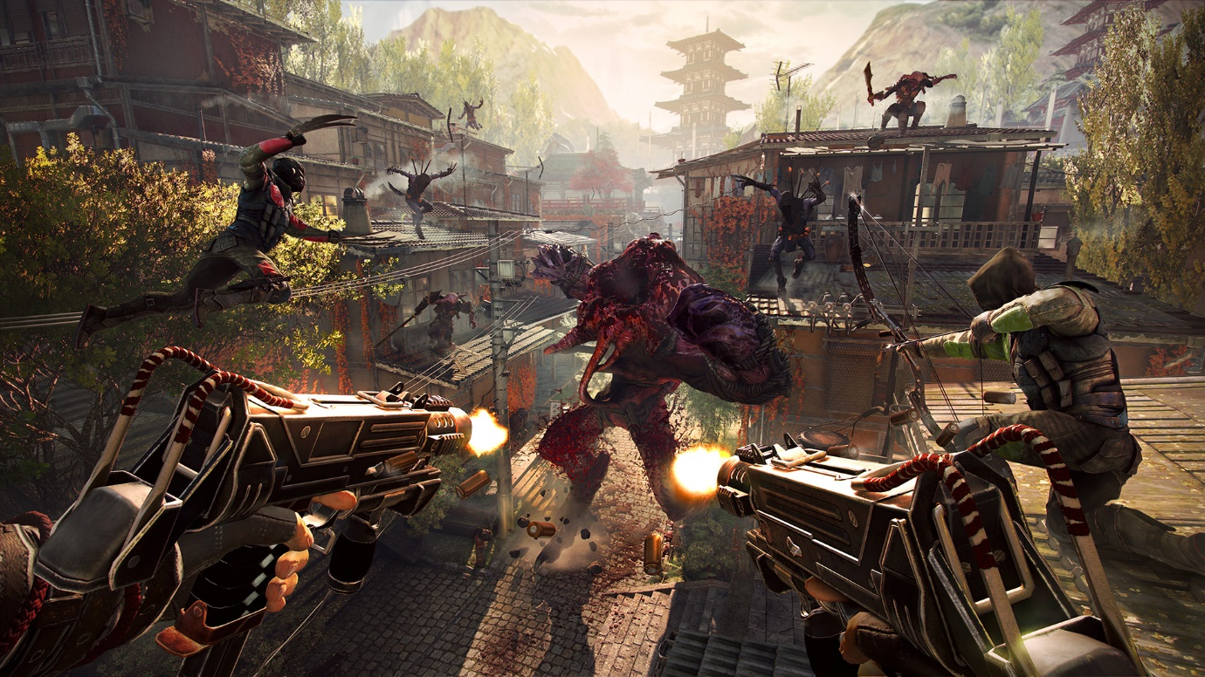

*Halo*

[*https://en.wikipedia.org/wiki/Halo_(franchise)*](https://en.wikipedia.org/wiki/Halo_(franchise))

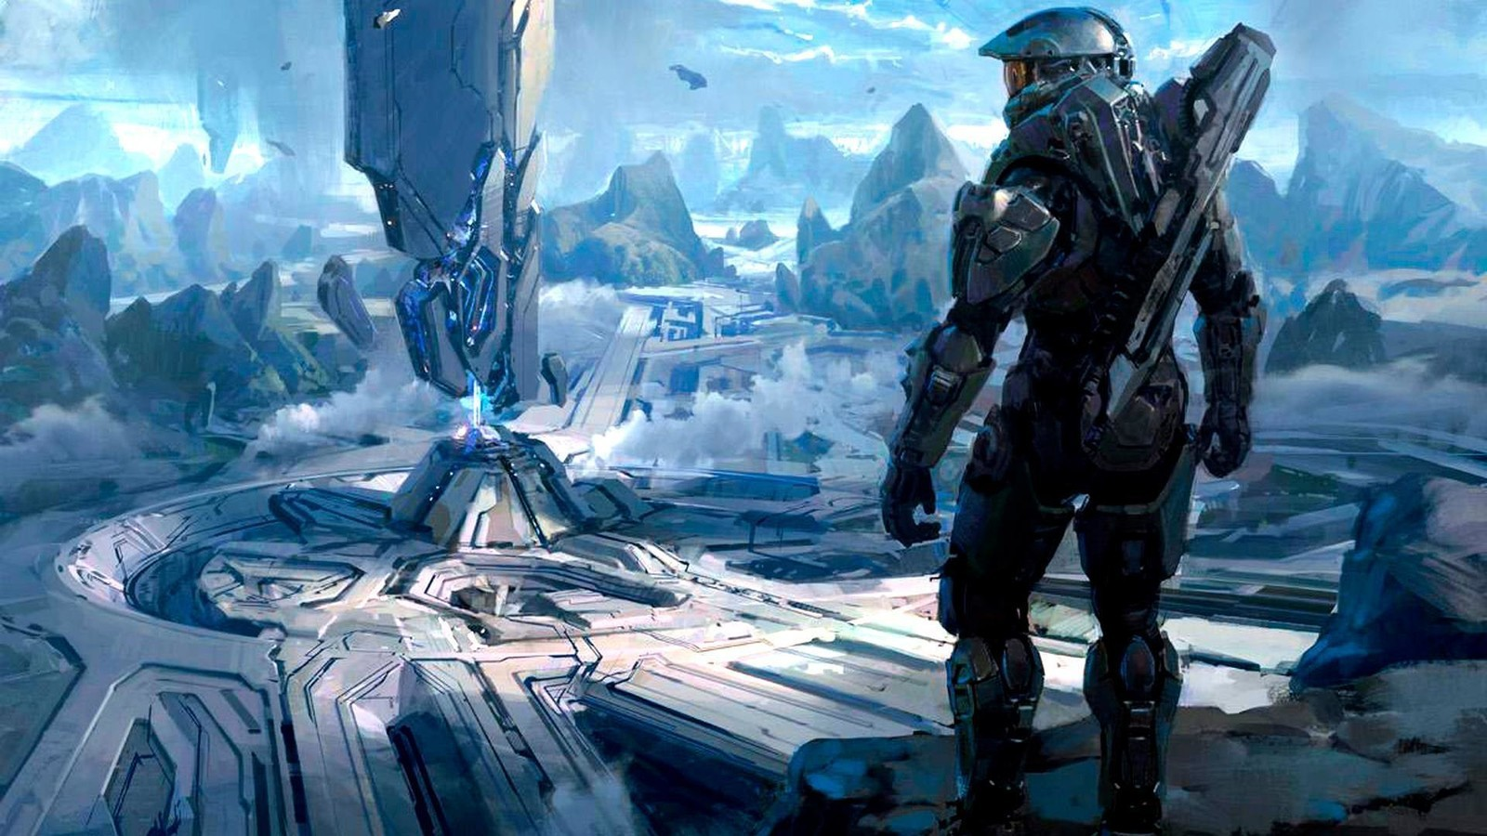

### Visual Inspiration and Influence

To begin the creation of the specific visual style of this game, reference was taken not only from other game environments but examples in both film and architecture. This was to create a style which is that of alien, robotic and digital, whilst appearing minimalist and imposing.

*Cypher*

<https://store.steampowered.com/app/746710/Cypher/>



<https://80.lv/articles/001agt-003qxl-005cg-setting-up-minimalistic-scenes-in-ue4/>

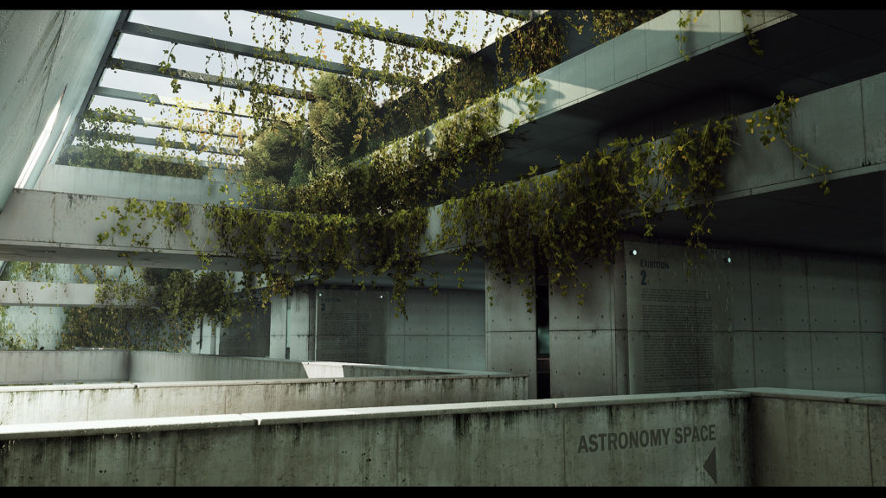

<https://www.archdaily.com/881356/barozzi-veigas-unbuilt-museum-project-immortalized-in-blade-runner-2049>

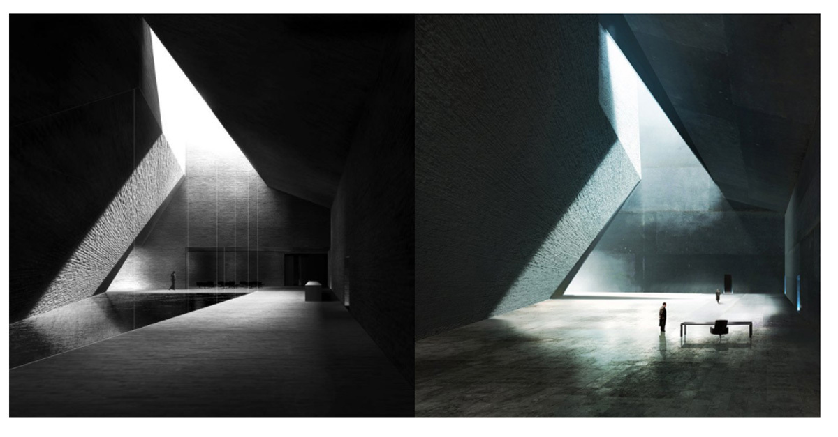

*Destiny ‘Vex’ Architecture*

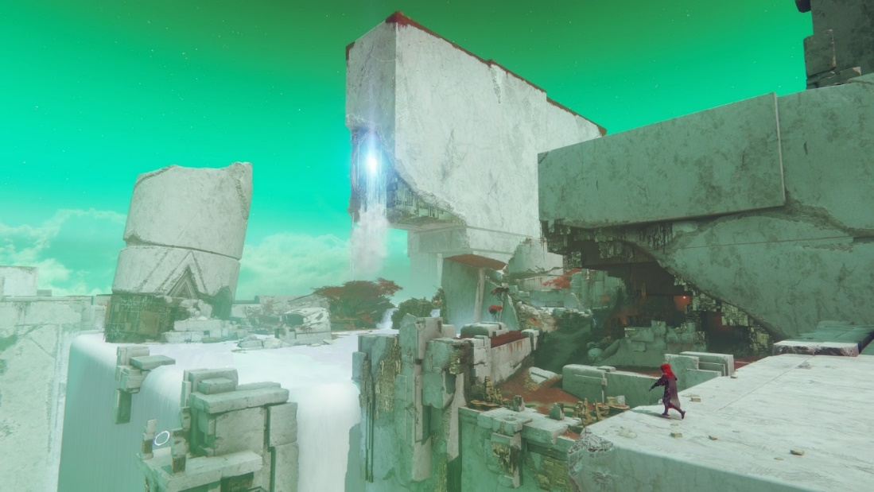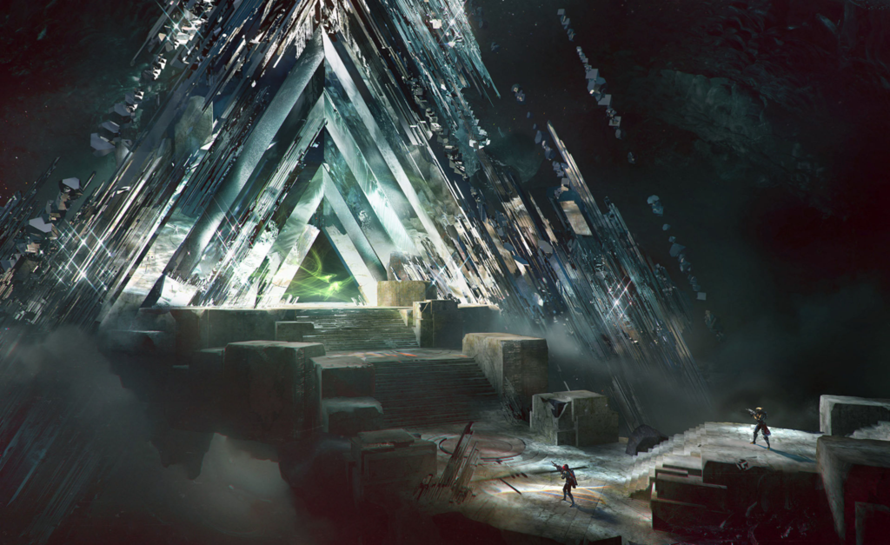

## Story

The game takes place on a once habitable planet, which has been consumed by a malicious artificially intelligent hivemind. The player plays as the last survivor of the former planet, surviving because they can use the hivemind’s technology against itself; the ‘Interloper’. To defeat the hivemind, the player must use all available resources to fight through the security forces and locate key systems across the planet to attack and destroy. Each level and boss the player encounters will represent a critical component of the hivemind structure.

## Gameplay

The player chooses what level to play by entering the corresponding door from the central hub level. They progress by following objectives and destroying enemies, and finally defeating a boss enemy to return to the hub. New weapons will be picked up throughout the game and added to the player’s inventory, growing their available options during combat. There will also be features such as collectible keys to open doors, buttons, jump pads etc.

The player will be able to use a variety of weapons to diversify gameplay:

Pistol: Unlimited Ammo, low damage

SMG: High rate of fire, low damage

Rocket Launcher: Low rate of fire, high damage, area of effect

Shotgun: Short range, high damage, spread

Sniper: Long range, high damage, high accuracy

Assault Rifle: Average range and damage

Burst Rifle: Precise, average damage, burst fire

DMR: Precise, high damage

Charge Rifle: Charge up, high damage

Grenade Launcher: Long reload, area of effect

## Controls

The player input will be similar to that of existing first-person shooters:

W/A/S/D Keys: Lateral movement

Mouse X/Y: Rotational movement

Left mouse button: Shoot

Right mouse button: Aim

Space: Jump

Scroll wheel: Switch weapons

E: Interact/pickup item

Q: Open weapon wheel, mouse to select weapon

Tab: Open player menu

Esc: Open pause menu

## Interface

Main Menu:

The main menu will have buttons to play, open the options menu, and to quit the game.

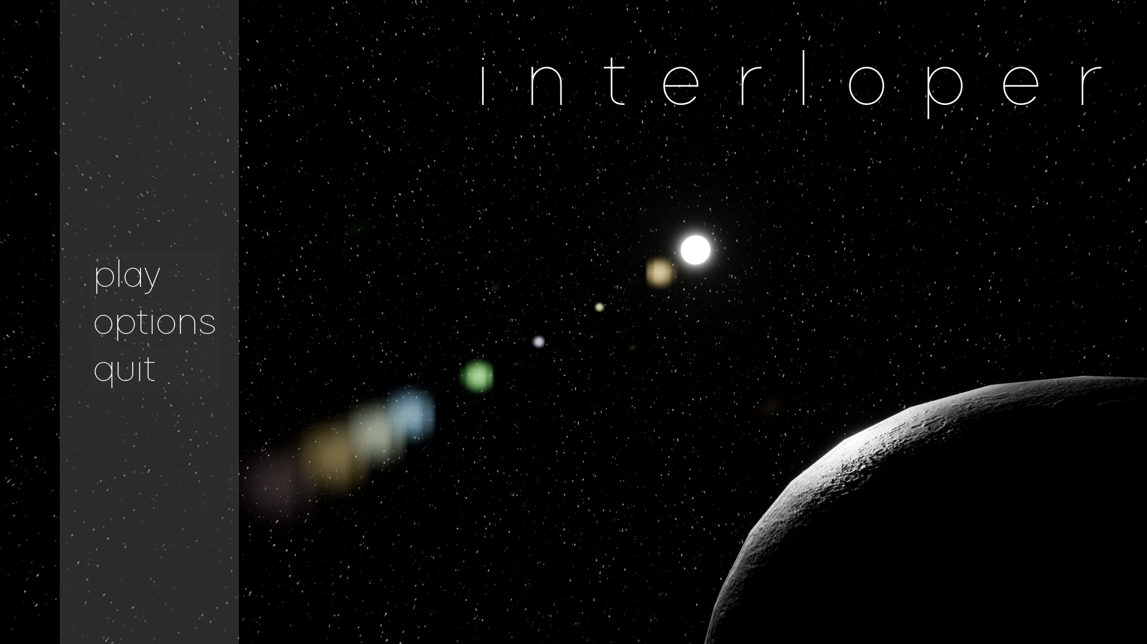

Options Menu:

The options menu will allow the changing of game properties such as the display and audio settings.

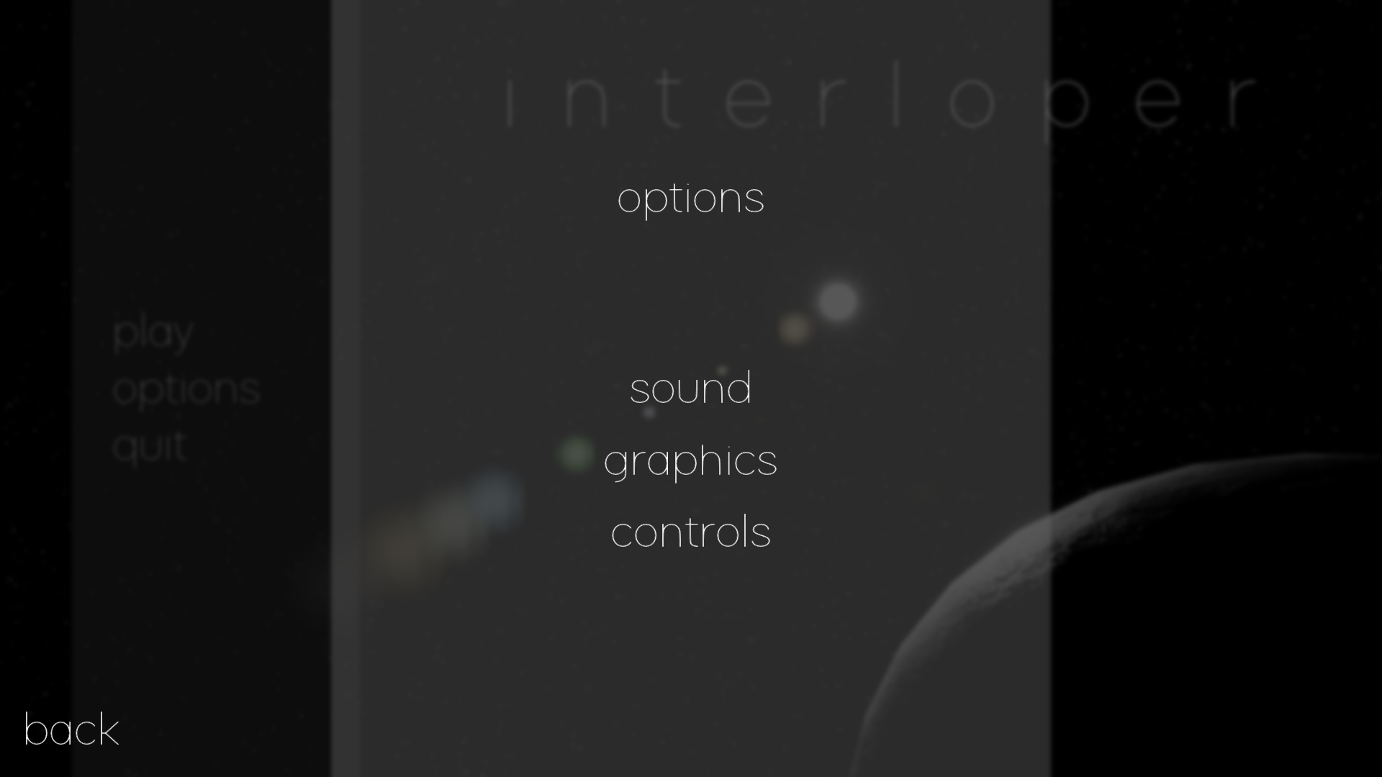

Pause Menu:

Will halt the game, and allow the player to also change options, quit, resume and load and save from a checkpoint.

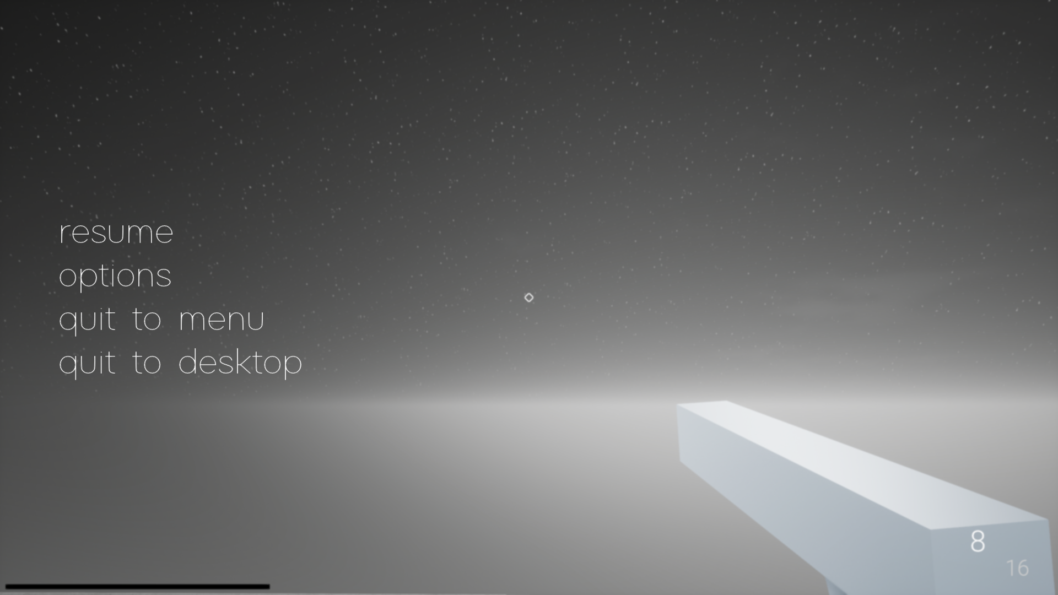

Weapon Wheel:

Allows the player to switch to a specific weapon they have unlocked by holding down a key and using the mouse to select a panel which corresponds to a weapon, which will then be equipped. Each option will have a specific icon depending on the weapon that will be switched to; e.g. the pistol weapon has an infinity symbol, to signify this weapon’s property of never running out of ammo.

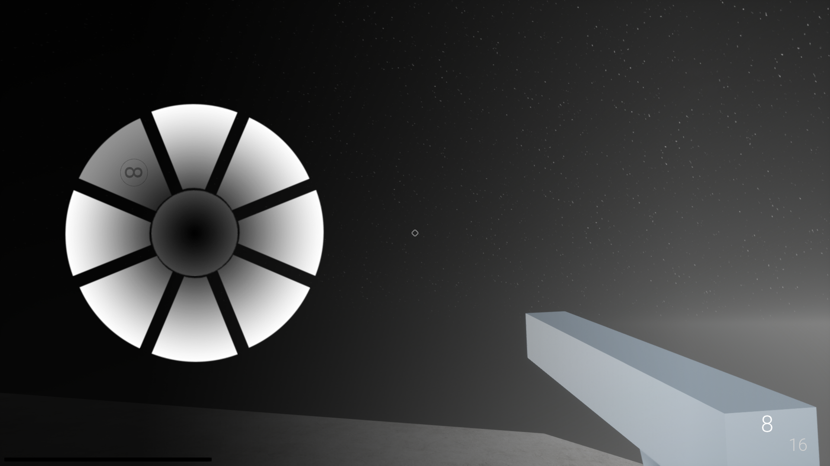

Objective Log:

To guide the player through the level, they will be shown a log of the current objective, with a visible marker in game over the direction or object the player must head towards.

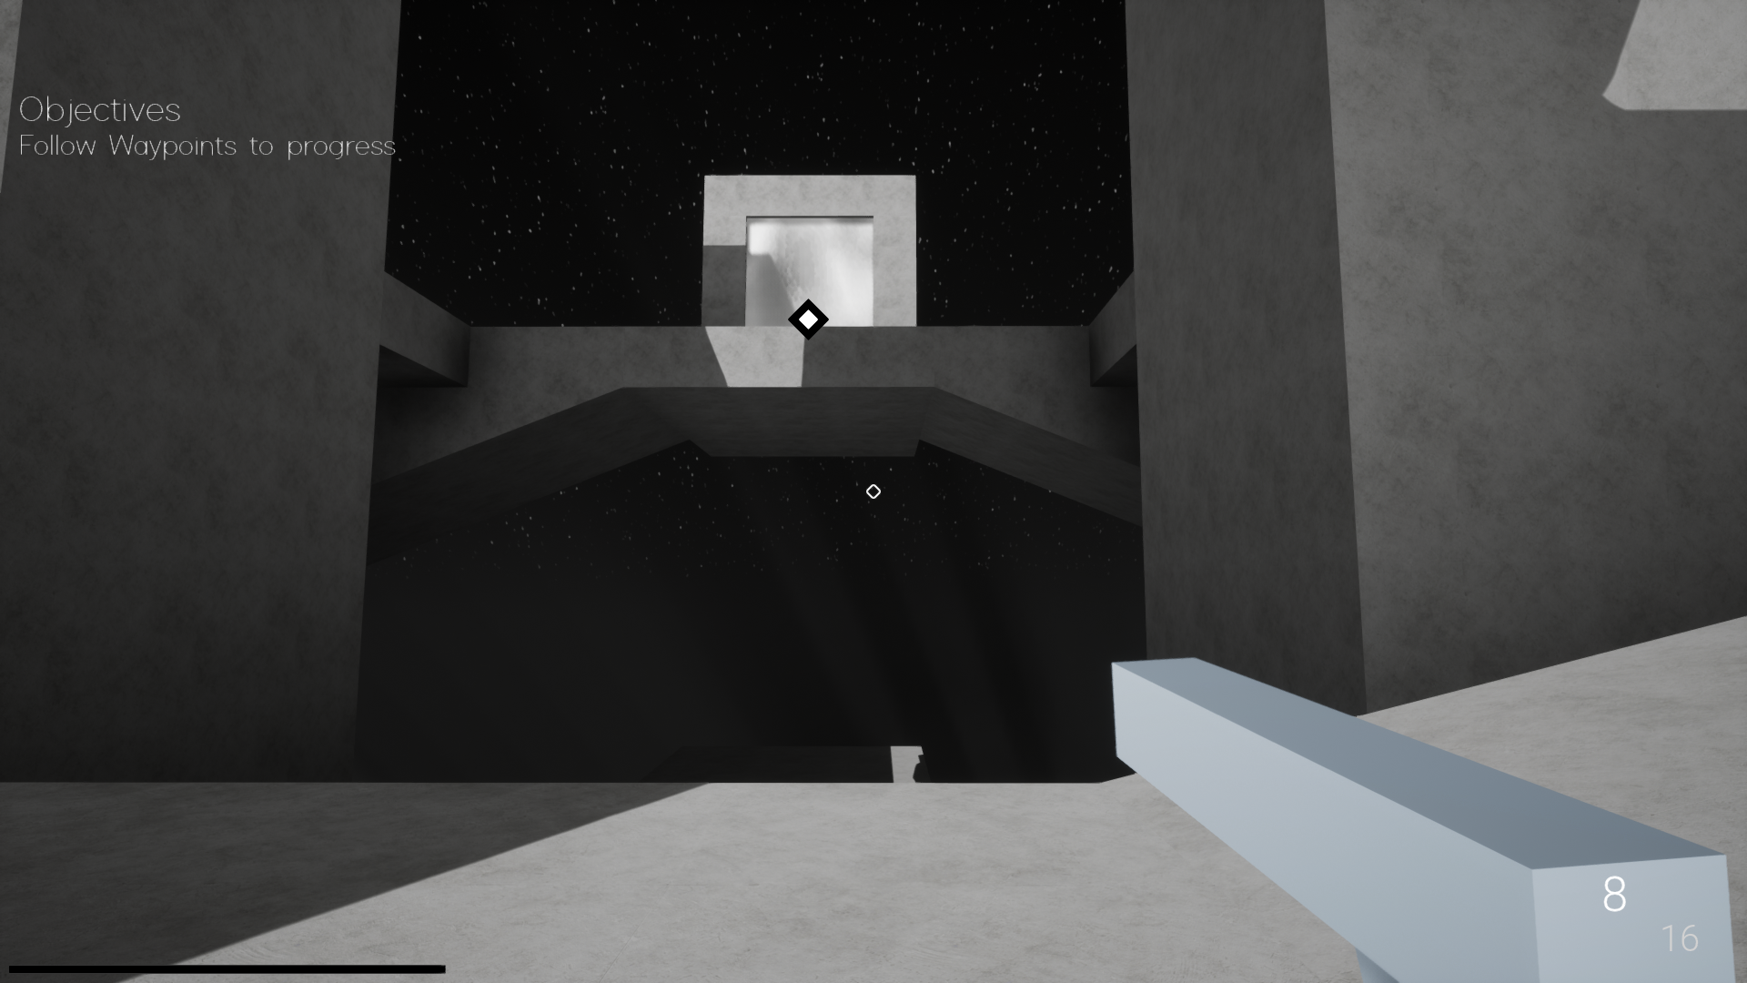

## Level Design

When the player starts a new game, they will be entered into a hub area, where they will be able to choose which level to play by entering the corresponding door. More levels will be unlocked by the completion of previous levels. Therefore, the game will be overall semi-linear.

The game world will consist of various levels, with areas for the player to explore and fight in. Each level will have the player defeat enemies throughout the level, then end in a boss fight which will unlock a weapon.

Levels will also include some further gameplay aspects such as picking up keys to open a door or defending an area for a period of time.

The intended atmosphere will be one of hostility, minimalism and scale; i.e. the idea that this world has be created by a force which has no sense of beauty or imperfection.

## Objectives

To progress the player will need to complete tasks which are tracked and shown on the interface. These can include collecting objects, moving to a certain location, or destroying specific enemies etc. These objectives are important to guide the player throughout the level, which is aided by the use of waypoint markers.

## Audio

Audio is important in establishing immersion; an important facet of this game as feedback to the player can be critical in a first-person game, as well as establishing an atmosphere in line with the game’s theme. The game will have ambient background music appropriate to the level, including the main menu. Each weapon will have distinct sounds for firing, reloading, and if the weapon has no ammo etc. Enemies will emit sounds when attacking and if they are attacked. Certain key parts of the game environment will also emit sound e.g. interactable objects such as objective items, health pickups, and ammo pickups. To add to the atmosphere, footstep effects and reverb will be implemented.

## Artificial Intelligence

The enemy characters are an important component of the game and will move and act according to their specified properties. This can be accomplished using Unreal’s behaviour tree and AI blackboard system, or AI specific blueprint implementation which was sufficient for most enemies. The AI uses a Navigation Mesh to calculate what surfaces of the game world it can traverse e.g. to allow it to avoid objects while moving, while using a Pawn Sensing Component to detect the Player.

The enemies’ appearances will be similar to the levels they inhabit; broadly imposing and monolithic and different depending on their abilities and attacks, i.e. tougher enemies will be larger, faster enemies will be smaller.

### Minion Enemies:

There will be several types of smaller regular enemies:

Melee Enemy: The most basic enemy, moves toward the player and must be close to attack.

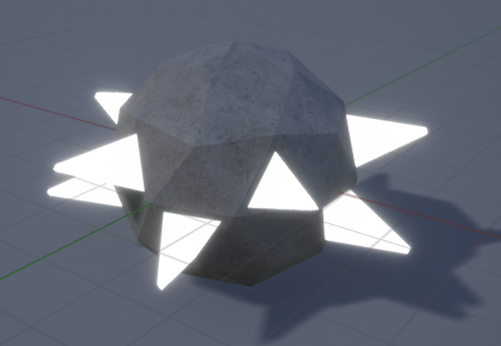

Bomb Enemy: Moves towards the player and explodes, dealing damage

Ranged Enemy: Moves to be within firing range of the player and shoots projectiles.

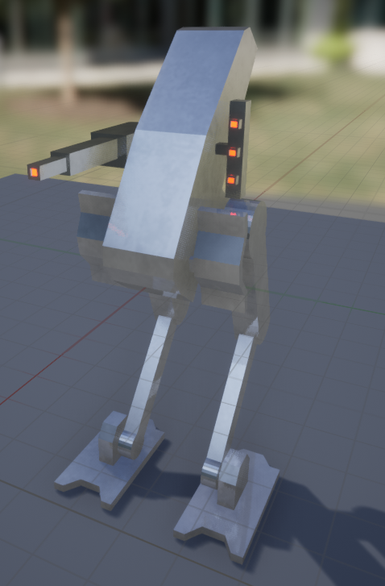

Sniper Enemy: Stays at range, shoots high damaging projectiles.

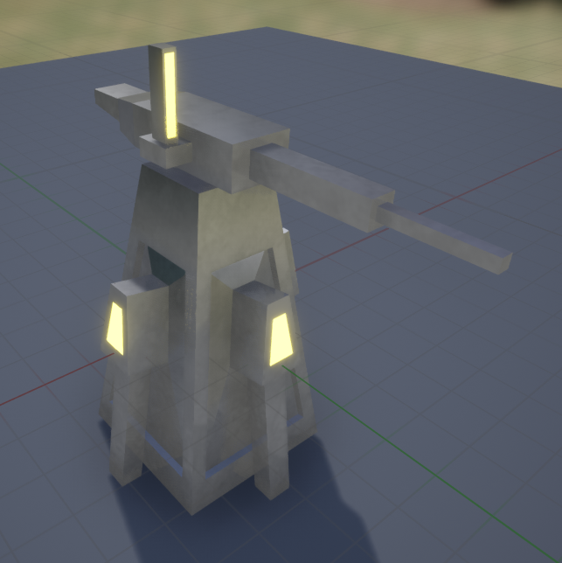

Grenadier Enemy: Ranged area of effect attacks, higher health value.

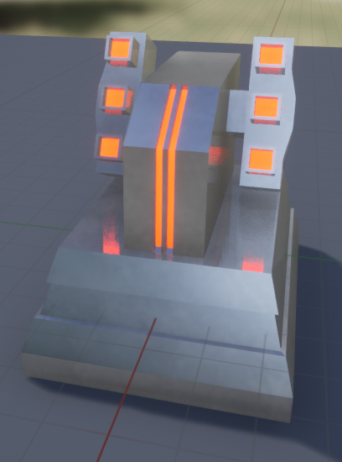

### Boss Enemies:

At the end of each level will be a stronger enemy with a dedicated arena. Each boss enemy will have a specific set of abilities and AI:

Boss 1: Stationary but rotates to shoot at player. Three stages, after each stage the boss becomes tougher, additional enemies spawn, gains new abilities and the arena shrinks in size.

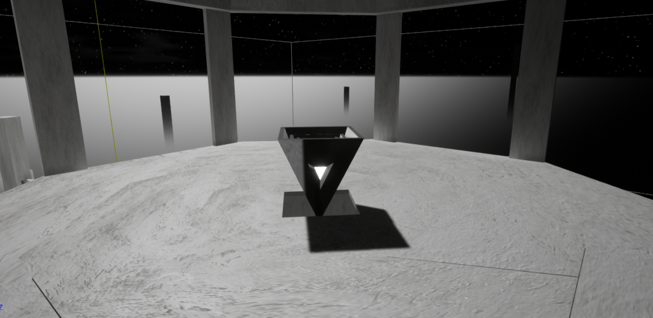

Boss 2: Walks around the arena to get a shot at the player, then uses a ranged attack with AOE damage, multiple other abilities.

Boss 3: More agile, difficult to hit, requires the player to predict its movements.

Boss 4: Player must hit critical weak points, defended by enemies

## References and Assets

* Sound Effect Assets: Freesound.com - <https://freesound.org/>
* Music Assets: Ultimate Game Music Collection - <https://assetstore.unity.com/packages/audio/music/orchestral/ultimate-game-music-collection-37351>

# Technical Design

## Platform

This game will be intended for the Windows PC with potential expansion to PS4 and Xbox One Platforms through the addition of controller input schemes and further optimisation for less powerful hardware.

## Hardware

The graphical quality of this game is not intended to be extreme, but some areas of the levels will be large with high quality lighting, and such could pose a stronger rendering challenge for the player’s hardware.

In terms of development, operations such as baking lighting across a level is highly hardware expensive, and such should be taken into consideration during level development.

Hardware Performance Survey:

|  |  |
| --- | --- |
| **Hardware** | **Average In-Game Frames Per Second** |
| Lab Hardware   * Intel Xeon E3-1245 * Nvidia Quadro K4000 * 16GB DDR3 | 42 |
| Primary Development Hardware   * Intel i7 8700 * Nvidia GTX 1060 6GB * 16GB DDR4 2400MHz | 62 |

Data can be collected of the game’s performance on different hardware configurations to aid in optimisation.

## Software

Unreal Engine 4.20 as a development environment to implement functionality and amalgamation of assets. Blueprint scripting was the primary method of feature implementation, along with other important tools such as the level editor and materials system.

Photoshop CC for texture editing and UI creation, exported as PNG.

Blender and Maya for 3D models and visuals, exported to UE4 as FBX files.

Audacity for audio editing, files exported as WAV as this is the standard audio file format for UE4.

Microsoft Office for documentation.

## Mechanics and Gameplay

Core game mechanics include:

* First person player controls
* Player shooting and ammo mechanics; ray casting and projectile spawning depending on the specific weapon
* Enemies and AI: Detection of player, movement, attacking
* Boss fights with special AI and actions
* Objective system

Additional Mechanics include:

* Item pickups; health, ammo, weapons
* Projectile system; to allow easy implementation of projectiles depending on properties such as the owner (player or enemy), or damage model (area of effect or direct damage).
* Waypoint system
* Player state saving ability; checkpoints

Mechanics such as the player’s weapons, projectiles and enemies will be class based, where each item is a variation on a base parent class which contains the majority of the shared code. This allows easier implementation of new objects without rewriting code, and therefore optimises both development time and performance.

## Development Environment

The environment for development of this project is Unreal Engine 4.20 using blueprint scripting for logic implementation. ‘Blueprint Scripting’ is a visual scripting interface within UE4 which allows rapid prototyping, especially if developers are not familiar with the C++ programming language native to UE4. This ability to prototype allows more gameplay to be implemented in less time, an important factor in this project due to the intended scope.

This engine was used as it has substantial support for the creation of first person games and high levels of graphical fidelity and lighting from default. These qualities are important to help achieve the project’s intended gameplay systems and visual atmosphere. For example; the engine has support for graphical features such as atmospheric fog, high quality skyboxes, global illumination, ambient occlusion and fog scattering, which are all utilised to create the required level of graphical immersion.

## User Interface

User interface elements will be created using the Unreal Motion Graphics (UMG) editor within Unreal Engine. This allows easier implementation of text, images, buttons etc. as well as functionality and communication with game code and player input.

Interactable interfaces in this game include:

* The main menu, with buttons to play, open options and quit. Options and Quit open separate UI panels with further interface elements.
* The options menu can change game volume, and display options such as resolution and graphics settings.
* The pause menu, with options to resume, save or load the game, change game options and return to the main menu.
* The player’s ‘heads up display’ (HUD), which displays information such as the player’s health and ammo
* An in-game weapon wheel, allowing the player to hold a button, while moving their mouse to quick select a weapon they have acquired. This will also pause the game to allow the player time to choose.
* Context sensitive interfaces, such as when the player can interact with an object, to display an objective indicator, or a boss’s health bar.
* Objective log, which displays on the HUD when a player receives a new or updated objective.
* Location specific waypoints, which can be seen through the game world on the player’s HUD, indicating important locations.

# Critical Appraisal

Overall, I am satisfied by the success of this project so far. Given the timescale a good prototype was able to be developed with many of the features required of the game as a whole. Development of the base graphics and audio were also completed to a degree I felt acceptable of the prototype, as well as development of a complete level.

Personally, I am very satisfied with what I have achieved on this project as a developer, given the timespan and workload. I have learned much over the duration of this section of the project, from further and more rapid implementation with Blueprint Scripting in UE4, audio development and the use of inheritance-based implementation, as well as the utilisation of a more fleshed out planning and documentation process.

Additionally, this project could have the potential to be overly ambitious, especially for a single developer and such time constraints, workload management and overall organisation were critical to ensure the development of an acceptable end product.

However, I am confident in the development of the project going into the second trimester such that the planning and preparation achieved so far will be of benefit to the creation of a final project of more than acceptable quality.